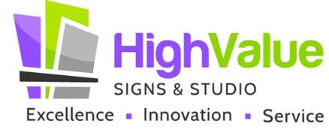
Administrative Assistant / Project Coordinator

Job Responsibilities:
Maintain customer records, answer phone and email inquiries, schedule site surveys and installations

Job Duties:
- Responds quickly and enthusiastically to phone, email, in person inquiries, documenting information from the inquiries
- Gathers information from customers or prospects and makes good notes
- Schedules site surveys and installations as needed; maintains the company calendar, making updates as needed if things change
- Sets up new customers in SignVox system, including things like company name, contact name, address, phone number, and email address and color codes, logos, or other assets
- Sets up Quotes in SignVox; converts Quotes to Orders and Orders to Invoices as jobs progress through stages
- Sets up files in shared drive; adds photos and documents following standard operating procedure
- Maintains up-to-date Customer and Vendor records in SignVox; adds new Customers and Vendors as needed
- Maintains shop and office supplies, ensuring proper amounts are in stock for needed activities
- Follows up on Quotes and Order, ensuring clear and consistent communication with Customers and Vendors throughout the process
- May assist the Sign Designer & Maker with production of signs
- Researches city sign ordinances and local codes and property manager requirements and summarizes for Sign Maker
- Performs other duties as assigned

Skills:
Excellent written and verbal communication skills, positive/upbeat attitude, well organized, high attention to detail, and superior follow through

Qualifications:
High School Diploma or GED
3+ years of experience as an administrative assistant or project coordinator
Valid driver’s license

About High Value Signs:
High Value Signs & Studio is a full-service commercial sign company located in Irving, TX serving Irving, Coppell, Lewisville, Grapevine, and Flower Mound and surrounding cities. We do lobby signs, building signs, monument signs, graphics for walls, floors, and windows, car and truck wraps and graphics, custom wall coverings, dimensional letters, and much more! High Value Signs offers customers custom signage solutions designed by an experienced marketing professional. We expertly project manage sign jobs to ensure they get done right and on time.

